**Math 252 Homework 7 Written Part Name:______________________________**

*Write legibly. Show your work. Graph neatly. Use a ruler for all straight lines.*

An example of integration by substitution with an indefinite integral -- notice the steps!

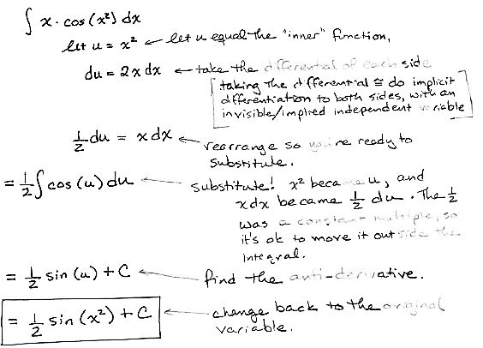

Showing your work neatly, completely, and correctly, find each integral:

1. 
2. 

An example of integration by substitution for a definite integral:

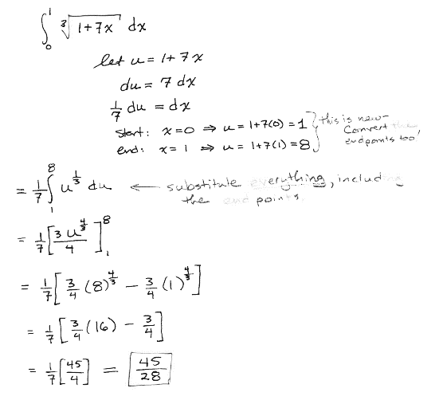

Showing your work neatly, completely, and correctly, find the integral:

1. 